Name: _____________________ Class:__________ Date:__________
Instructions: Write answers in the right-hand column. Score: ___________ / 60 marks
Section A – Multiple choice (10 marks)

 | Recall the number of chromosomes contained by each human egg or sperm.  - 23 chromosomes  - 46 chromosomes  - 23 pairs of chromosomes  - a diploid number of chromosomes | A | 1
 | The gametes of a fruit fly have four chromosomes. Deduce the diploid number for the fruit fly.  - 2  - 4  - 6  - 8 | D | 1
 | The structure of DNA may be described as a twisted ladder. Recall what forms the upright parts of the ladder.  - alternating sugar and phosphate units  - nitrogen bases  - amino acids  - protein | A | 1
 | Recall the number of chromosomes in cells after meiosis, compared to the original cell.  - double  - same  - half  - quarter | C | 1
 | A biology student wants to examine gamete formation. Deduce the most suitable prepared slide for her to examine.  - human skin  - rat testes  - early developing embryo  - human bone marrow | B | 1
 | Deduce when the sex of an individual is determined.  - when the egg is formed  - when the sperm is formed  - when the egg is fertilised by the sperm  - when the embryo is 12 weeks old | C | 1
 | Meiosis is also referred to as ‘reduction division’ because it produces daughter cells containing the haploid number of chromosomes. Propose where meiosis would typically occur.  - division of skin cells  - production of gametes  - replication of red blood cells  - replacement of damaged muscle cells | B | 1
 | Recall where chromosomes are found.  - in the nucleus of most cells of your body  - in the nucleus of brain cells only  - in the nucleus of reproductive cells only  - in the nucleus of stem cells that have not yet differentiated | A | 1
 | Most cells in your body contain two of each type of chromosome (i.e. they have 2N chromosomes). Recall the exception to this.  - diploid cells  - body cells  - gametes  - homologous cells | C | 1
 | 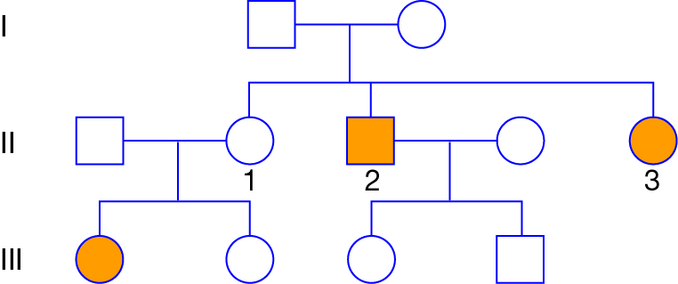  This pedigree shows a recessive inherited condition, which is indicated by the yellow colour. Male parent 2 has the condition but his female partner does not. Identify the correct statement for their children.  - Their children are carriers of the condition.  - Their children are homozygous dominant for the condition.  - Their children will not have children with the condition.  - Their children are homozygous recessive for the condition. | A | 1

Section B – Short answer (40 marks)

- ` | Explain the differences between each pair of terms.  a X chromosome, Y chromosome  b meiosis, mitosis  c genotype, phenotype  d heterozygous, homozygous | a The X chromosome and Y chromosome are both associated with sex determination. In most animals, the female has two X chromosomes while the male has one X chromosome and one Y chromosome.  b Meiosis and mitosis are both types of cell division. Meiosis produces cells with half the number of chromosomes of the parent cell. Mitosis produces two daughter cells identical to the parent cell.  c The genotype is the genetic information carried by an individual. The phenotype is the observable characteristics of the individual, i.e. the way the genotype is expressed as it interacts with the environment.  d Heterozygous means having two different alleles on homologous chromosomes. Homozygous means having two alleles the same on homologous chromosomes. | 4
 | a Identify which of the following statements are true and which are false.  b Modify the false statements so that they are true.  1 A gamete produced by mitosis has the haploid number of chromosomes.  2 A chromatid is one of two identical strands into which a chromosome separates during mitosis.  3 Alleles are alternative forms of a gene found at the same locus on a chromosome.  4 Homozygous individuals possess two different forms (alleles) of a particular gene, one inherited from each parent.  5 An autosome is any chromosome that is not involved in sex determination.  6 The phenotype of an organism is the organism’s entire genetic make-up, or the sum total of genes (DNA) that it possesses.  7 A mutation is a sudden change in a gene that can be inherited.  8 The process of fertilisation halves the chromosome number of an organism. | 1 False. A gamete produced by meiosis has the haploid number of chromosomes.  2 true  3 true  4 False. Heterozygous individuals possess two different forms (alleles) of a particular gene, one inherited from each parent.  Alternatively, homozygous individuals possess two copies of the same allele of a particular gene, one inherited from each parent.  5 true  6 False. The genotype of an organism is the organism’s entire genetic make-up, or the sum total of genes (DNA) that it possesses.  Alternatively, the phenotype is the observable characteristics of the individual.  7 true  8 False. The process of fertilisation (i.e. the joining together of two gametes) restores the diploid chromosome number of an organism. | 8
 | The diagram below shows a simplified illustration of the stages of meiosis. However, the stages are not in the correct order. Identify the correct order and write the letters corresponding to each stage in order.  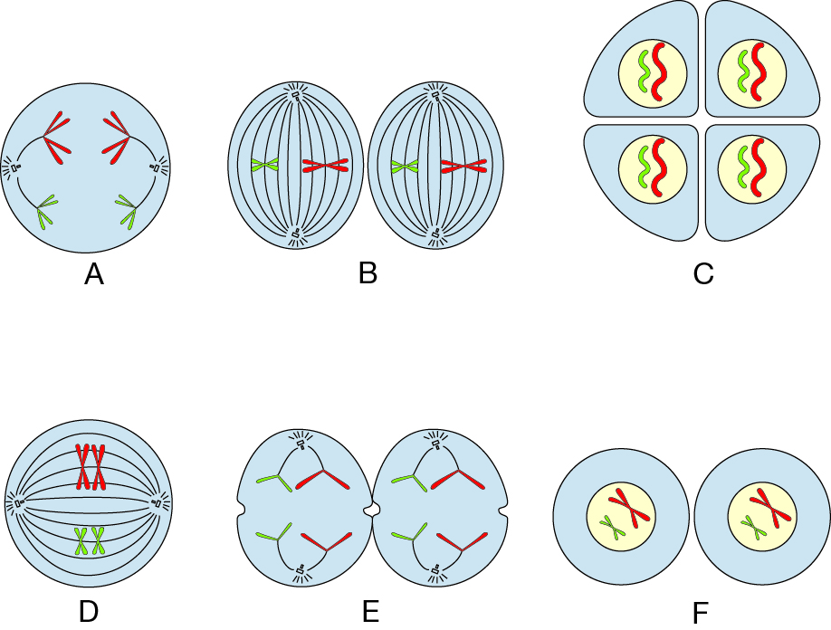 | D A F B E C | 3
 | Dwarf peas are crossed with heterozygous tall peas. If tall is dominant over dwarf, predict the phenotype and genotype ratios of the F1 generation. Show notation and working. | T: tall (dominant); t: dwarf (recessive)  Half of the F1 generation is expected to be heterozygous tall and half to be dwarf peas (genotype tt); that is, a ratio of 1:1. | 4
   | T | t
  t | Tt | tt
  t | Tt | tt
 | The diagram below shows the stages involved in gene technology using recombinant DNA. Explain what is happening in:  a stage 2  b stage 4  c stage 5  d stage 7.  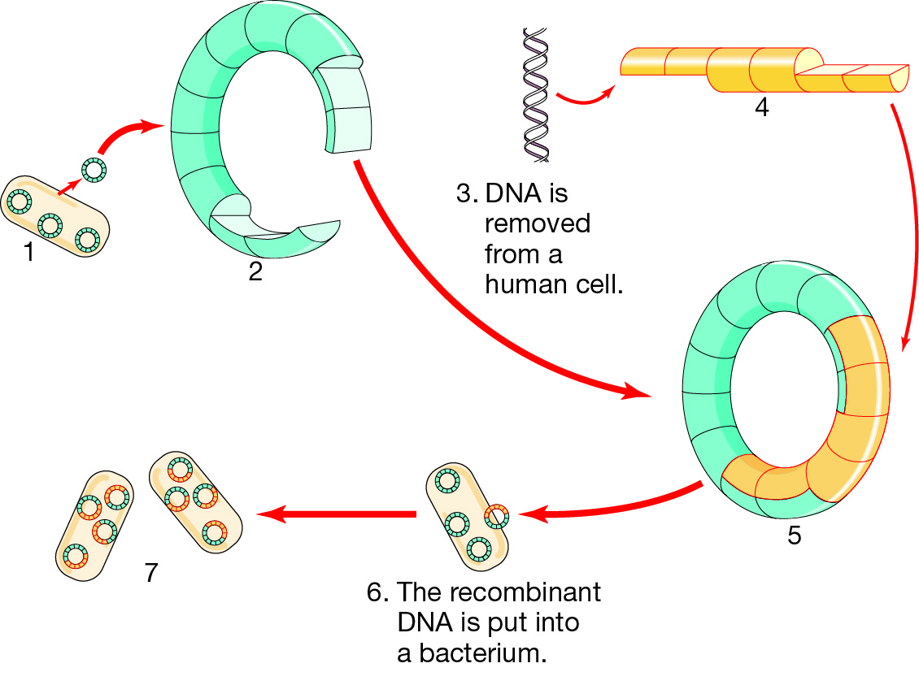 | a The plasmid is cut using an enzyme.  b DNA is cut using an enzyme to isolate a gene – the beneficial gene.  c The beneficial gene is inserted into the plasmid to form recombinant DNA.  d Bacterial cells grow and divide to produce many copies of the introduced gene. | 4
 | Haemophilia is an X-linked recessive disease. The symbol XH is used to show the normal gene on the X chromosome, and the symbol Xh is used to show the recessive gene on the X chromosome.  a State the possible genotypes of a:  i haemophiliac male  ii non-haemophiliac male  iii non-haemophiliac female.  b A female may be a ‘carrier’ of the disease.  i Clarify what is meant by the term ‘carrier’.  ii State the genotype of a ‘carrier’. | a i XhY  ii XHY  iii XHXh or XHXH  b i She has a gene for the disease but not the disease itself (no symptoms).  ii XHXh | 6
 | In relation to the study of genetics:  a State what the letters DNA stand for.  b State what the letters A, C, T and G stand for in a DNA base sequence. | a deoxyribonucleic acid  b the four bases: adenine, cytosine, thymine and guanine | 3
 | Describe the following.  a recombinant DNA technology  b Human Genome Project  c gene therapy  d cell differentiation | a Technology whereby the DNA of one organism is recombined with genes from another organism.  b The international project aiming to identify all human genes and to determine the sequences of base pairs that make up human chromosomes.  c The process of replacing a defective gene with a normal gene. This technology is still in the experimental stage.  d Cells in an embryo are initially identical. As the embryo matures, cells take on specific characteristics and become different from each other. This is the process of differentiation. | 4
 | Compare embryonic stem cells and adult stem cells. | Embryonic stem cells are found in the embryo. They can become any type of cell found in the adult organism.  Adult stem cells are found in the skin, the brain and the lining of the gut. They can become different types of cells, but the types are limited. | 2
 | Demonstrate how different genotypes can produce the same phenotypes, giving examples using the allele labels ‘M’ and ‘m’. | ‘M’ denotes the dominant allele and ‘m’ denotes the recessive allele. The dominant allele is evident in an individual’s phenotype whether the individual is homozygous or heterozygous for the trait. Therefore, the genotypes MM and Mm will have the same phenotype despite having different genotypes. | 2

Section C – Thinking scientifically (10 marks)

 | In a certain organism’s DNA, 10% of the bases are thymine. Calculate the percentage of bases that would be guanine.  - 10%  - 40%  - 80%  - 90% | B | 1
 | Deduce the number of possible types of gametes that could be produced when a cell with three pairs of chromosomes undergoes meiosis.  - 3  - 4  - 6  - 8 | D | 1
 | In humans, albinism (a total lack of pigmentation) is inherited as a recessive trait. If an albino man and a non-albino woman (whose father is albino) have a child, calculate the probability that the child is albino.  - 0  - ½  - 1  - ¼ | B | 1
 | 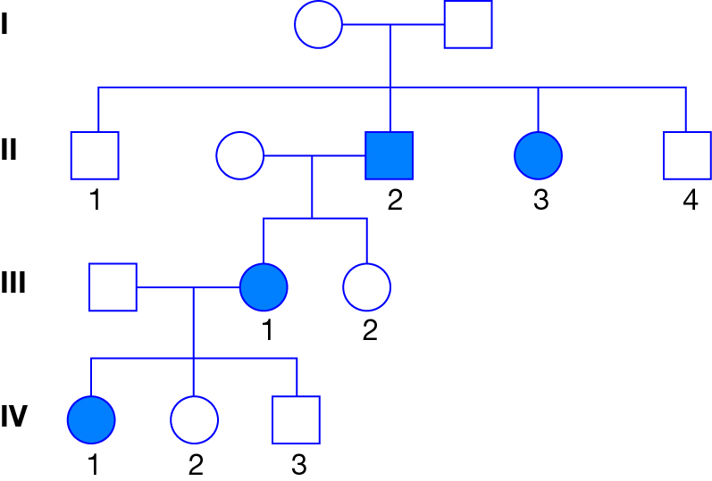  The pedigree above shows the inheritance of a disease (shown in blue) caused by a recessive gene ‘g’. Those with the dominant gene ‘G’ do not show the disease. Identify the genotypes of the parents in generation I.  - female Gg, male GG  - female GG, male Gg  - female Gg, male Gg  - female GG, male GG | C | 1
 | The pedigree above shows the inheritance of a disease (shown in blue) caused by a recessive gene ‘g’. Those with the dominant gene ‘G’ do not show the disease. Identify the genotypes of the following individuals in order:  Generation II number 3; Generation III male; Generation IV number 2.  - Gg, gg, Gg  - gg, Gg, Gg  - Gg, Gg, Gg  - gg, gg, Gg | B | 1
 | Scientists researching genetic modification use a particular enzyme to cut a piece of DNA. The exposed ends of the DNA are shown in the figure below.  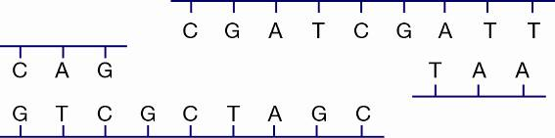  From the four genes below, identify the gene that could be spliced into the piece of DNA above.  - 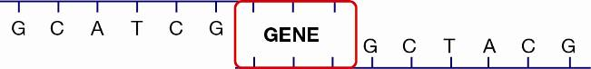  - 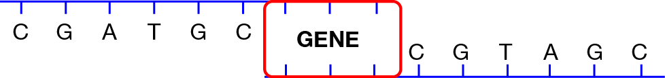  - 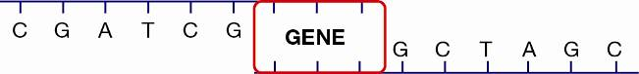  - 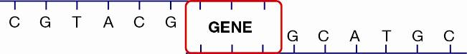 | C | 1
 | 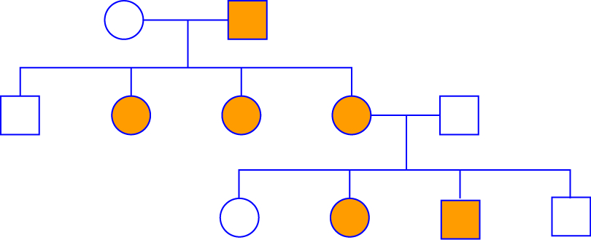  In this family tree, individuals represented by yellow squares or circles carry a particular trait. Analyse the pedigree and decide how the characteristic is inherited.  - recessive trait carried on the X chromosome  - dominant trait carried on the Y chromosome  - recessive trait carried on an autosome  - dominant trait carried on the X chromosome | C | 1
 | 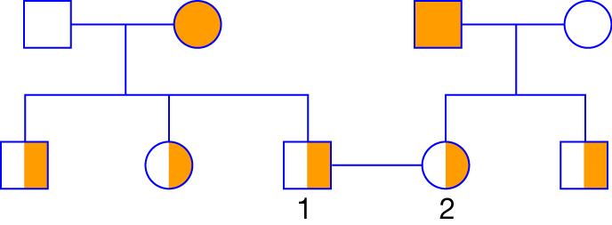  Calculate the probability that any children of individuals 1 and 2 are carriers of the recessive trait shown in yellow in this pedigree.  - 75%  - 50%  - 25%  - 0% | B | 1
 | 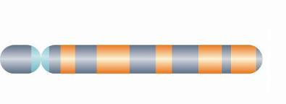  The figure above shows one half of a homologous pair of chromosomes. Identify the other homologous chromosome.  - 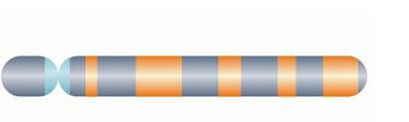  -   - 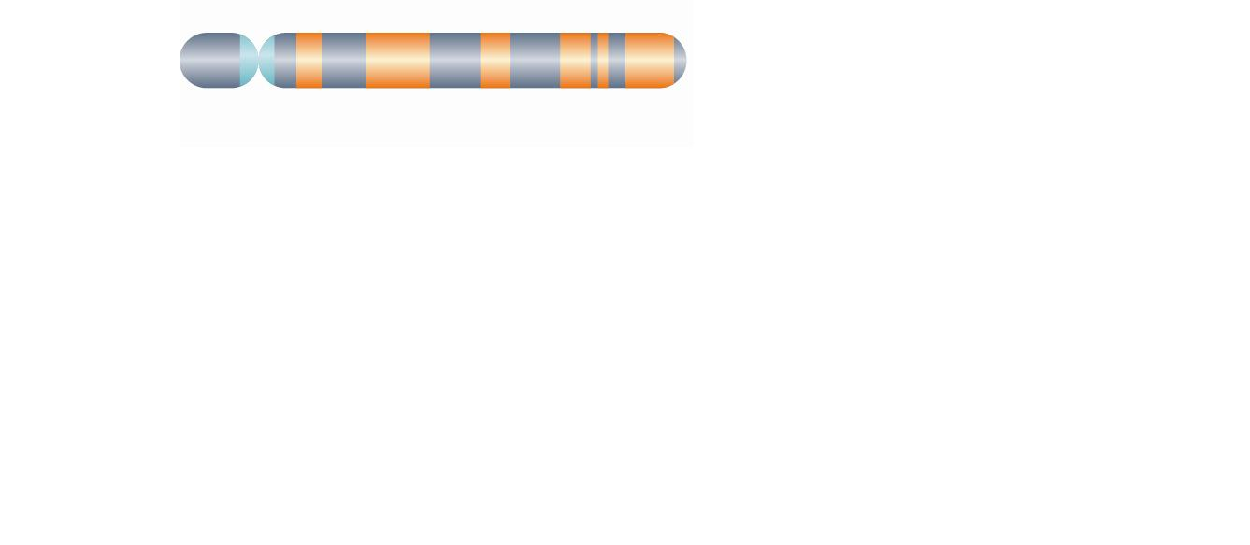 | A | 1
 | ACGTCAATGCATG  Half of a strand of DNA bases is shown above. Identify the complementary DNA strand.  - TGCAGTCACCTAC  - TCCAGTTACGTAA  - TGCAGTTACGTAC  - TGCAGATACTTAC | C | 1

